Team Project

Deliverable 3 – Project Phase 1

CSCE 5430 (Fall 2020)

**Due Date:**

• Code (project repository): 10/14, 11:59pm

• A file containing core functionalities (project repository): 10/14, 11:59pm

• Report (project repository): 10/14, 11:59pm (11/12 point, single space, 5-8 pages)

• Demo: 10/15 in class (PowerPoint, 5 minutes per group)

**Weight**: 14% of the final grade

**Late Policy:** 10% deduction per day.

**Deliverables:**

This is the first implementation phase of your project. For this part, you will hand in a working program based on the specifications you developed for Deliverable 2 along with the design document and test cases. In addition, you will provide a user manual and installation instructions.

3.**Report:** One document (e.g., Deliverable-3.pdf) that contains the following items:

**a. Requirements**

List the set of requirements designated for this development phase.

• If the scope for this phase is unchanged, use the same requirements of phase 1 specified in Deliverable 2.

• If not, explain the reasons why the plan is changed and describe the updated plan including the modified set of requirements for all phases.

**Development Phase 1**: We are with the initial plan for the phase 1 development. Therefore, giving a brief description of the phase 1 requirements and functionalities from deliverable-2.

|  |
| --- |
| **UI - HOME PAGE**- The home page contains everything the user is looking for in a quick glimpse. It has transitions which will walk the user through our hotel experience. When we scroll down in a home page, we see the types of rooms we offer including the elaboration of the kind of services out hotel provides. When we go the very bottom of the home page, we see the user reviews which are posted to our website and a book now option which navigates us to the booking page.  **UI – REGISTRATION**- In the registration page we have to fill up the basic user contact details like the username email address phone number and address and click sign up where the user will be able to use his id from the next time while booking. In the registration page few fields have conditions for example when we consider password must have at least one upper case letter, one lower case, one number and it should be 8 characters in minimum. The first name and last name should not contain numbers and the email should be valid. |
| **DATABASE USER DATA LINKING** – We use MYSQL in the back end to store the user data in the tables. This data is linked through php and once we click the sign up or submit button in the registration page the data is stored in the respective tables in the back end. When the user logins from the login page the data is fetched from the backend and verified if the user data is correct or not and then proceeds to login. |
|  |
|  |
|  |

• **Class diagram**

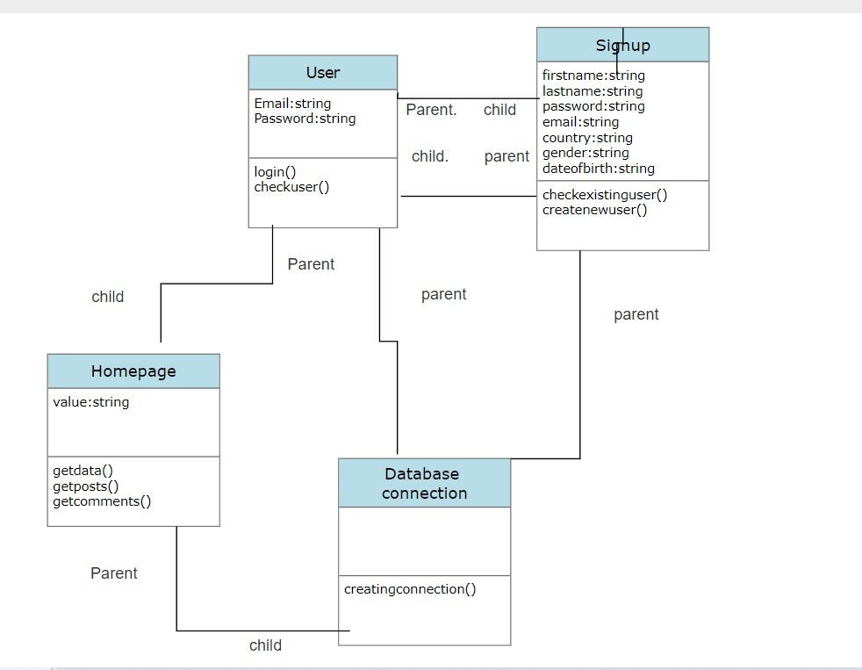

**• Sequence diagram**

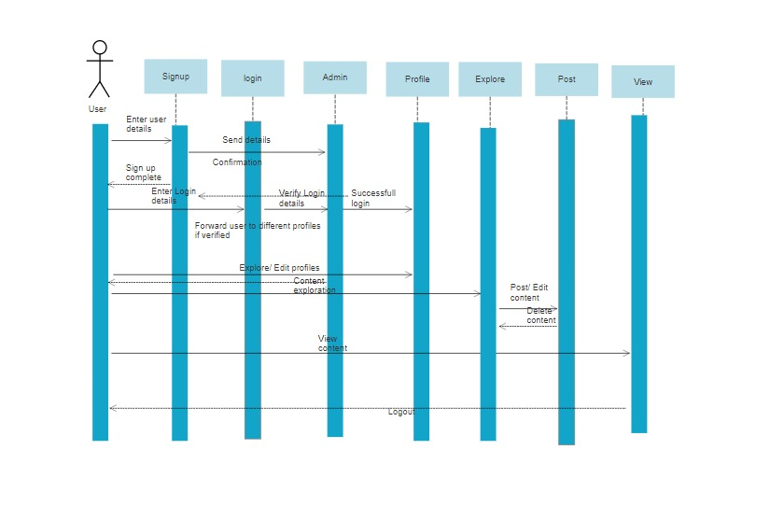

**• Use case diagram** – one normal case and one error case should be included.

**Use case error case**

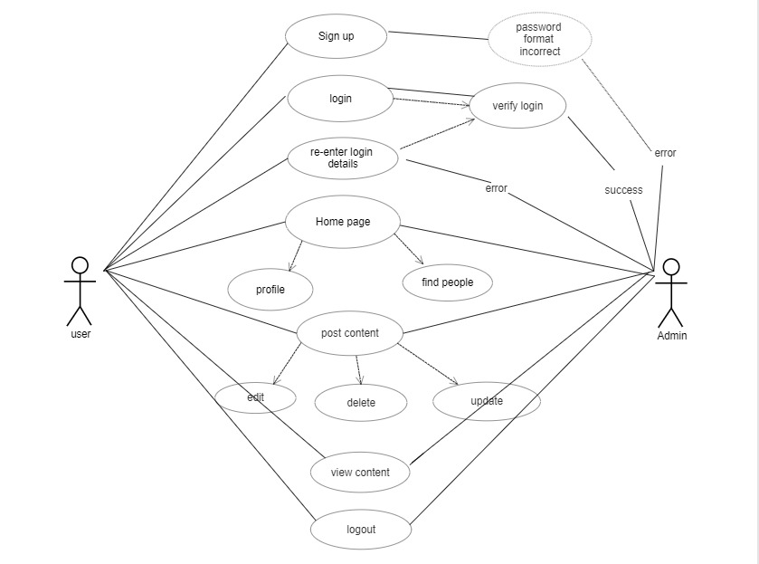

**Use Case**

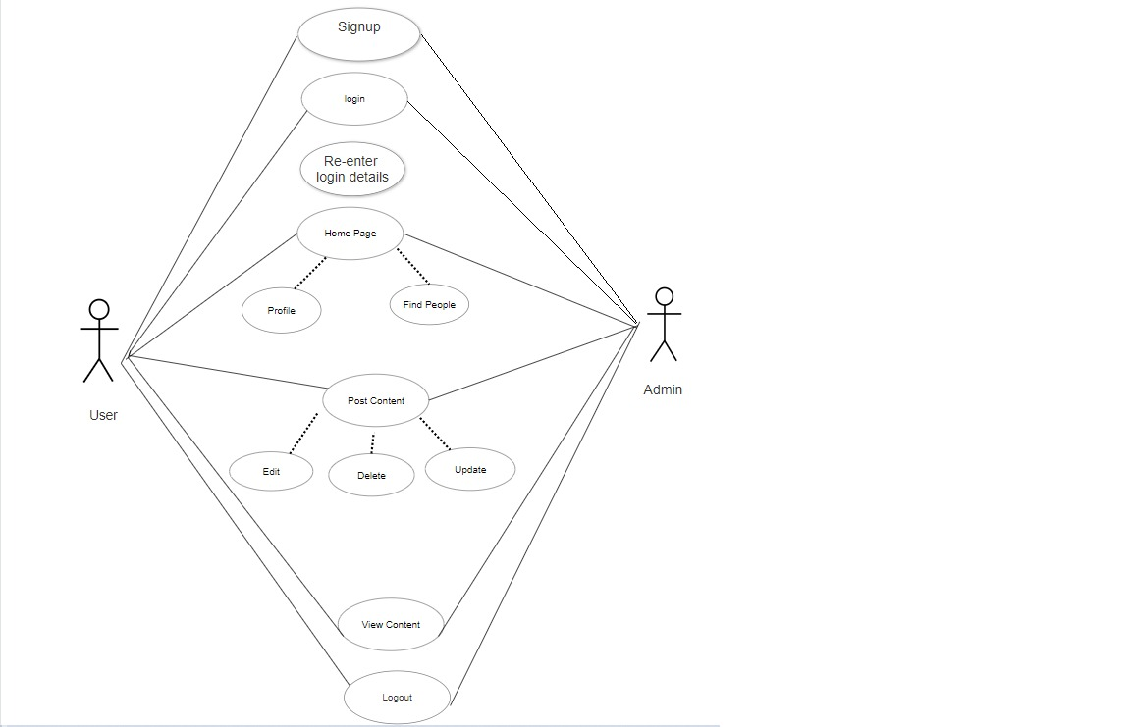

**c. Test Cases (unit tests)**

List a set of test cases used for testing the working program including descriptions of tests (e.g., what functionality they test, and inputs/outputs for them)

|  |  |  |  |  |
| --- | --- | --- | --- | --- |
| Test Case Number | Functionality | Expected result | Actual result | Success/Failure |
| 1. | Registration:  Enter all the required fields. First Name, Last Name, Password (Less than 8 Characters), Email, Country, Gender and Date of Birth. | Incorrect data | Incorrect data | Fail |
| 2. | Registration:  Enter all the required fields. First Name, Last Name, Password (equal or greater 8 characters), Email, Country, Gender and Date of Birth. | Match the right format | Match the right format | Success |
| 3. | Registration:  Enter all the required fields. First Name, Last Name, Password, Email(already existing email), Country, Gender and Date of Birth. | Incorrect data | Incorrect data | Fail |
| 4. | Registration:  1.Enter all the required fields. First Name, Last Name, Password, Email, Country, Gender and Date of Birth.  2.Click on signup | Enters the home page | Enters the home page | Success |
| 5. | Login:  1.Enter all requires fields. Username(invalid username) and password(invalid password)  2.Click Login | Incorrect data | Incorrect data | Fail |
| 6. | Login:  1.Enter the username and password  2.Click Login | Enters the home page | Enters the home page | Success |

**d**. A user manual that tells us how to install/use your program. This is meant for the end-user of the software. You may include screen shots, where appropriate.

**Answer:** Questionnaire User Manual

**Login page**

* Any registered user with a valid Email ID and password can login to their account from this page.
* After entering the required details, a click on the Login button will navigate the user to homepage.
* If an invalid email address or password is provided by the user, then it displays an popup saying “Incorrect details, Try Again”
* For the new users who want to register can click on “Don’t have an account” which takes the user to registration.

**Registration Page:**

* Any user can register himself/herself by filling out the following details, First Name, Lastname, Password, Email, Gender, Country, and Date of Birth.
* All the details marked with red asterisk are mandatory to register and a warning “Please fill out this field” error is generated.
* On clicking the Sign-up button, the system validates all the information provided and creates an account in the database if it is valid.
* User is once again navigated to login page where his credentials are validated and then will be taken to homepage.

**Constraints while Registration:**

* If an existing (already registered) user tries to register, it displays an error message pop up saying, “Email already exist, Please try another”.
* A user must enter the password that contains at least a one uppercase letter, one lowercase letter, and must be of length of 8 or more characters.
* If required conditions are not met, then an error stating “Must contain at least one number and one uppercase and lowercase letter and at least 8 or more characters”
* Only letters are allowed while filling out first name and last name. Few special characters and numbers are restricted

**e**. Clear instructions on how to compile/run both your program and your test cases (the program must compile/run).

**User manual to test and use the code: E. Instructions on how to compile and run.**

1. Download and install XAMPP in your system.
2. XAMPP for windows 7.1.32 64 bit version
3. Once XAMPP is installed, start Apache and MySQL.
4. A screenshot of a computer

   Description automatically generated

5.Change the port number on clicking the config button if there is any conflict while starting with Apache and MySQL

6. Place the executable folder i.e.

7. Open localhost/Techno8/Signin in the browser which will open the homepage of the website

8. Click on the php files to run the php file

9. As soon as website opens, we see the login page

f. A section that briefly describes feedback received during the peer review session and actions taken based on the feedback.

**Answer**: Peer Review Feedback & Action Taken

In the peer review, we are asked to work on adding the following features and make some cosmetic changes. Some of the discussed changes like adding a security question will be done by next deliverable

•Constraint on first name and Last name: Added a constraint which only allows letters and restricts numbers and some special characters.

•Constraint on existing user: if an already existing user tries to register the system will not allow and generates an error message.

g. A brief reflection on what has been accomplished, what went well and could be improved.

**Answer:** Accomplishments and Improvisation

We have planned to construct a homepage, login page, registration page and creation of data model and database in our phase 1 which are all successfully met by this deliverable. We are planning few improvisions like adding new features like forget password which would send a link to create new Password to registered mail, Remember Me. We are also planning on adding a security question at the time of registration. For the next deliverable we are planning on building a home page, Profile page with edit options

h. Member contribution table (should describe who wrote what components or classes of the system and what parts of the report.

**Member contribution table**

|  |  |  |  |
| --- | --- | --- | --- |
| Member name | Contribution description | Overall Contribution (%) | Note  (if applicable) |
| DEEPTHI POTHINENI | Backend Developer, Documentation | 12.5% | Worked on login page code inspection |
| BINDU JAMMULA | Requirement Gathering, Testing | 12.5% | Worked on deliverable document and test cases |
| KEERTHI CHINTA | UI Developer, Presentation | 12.5% | Worked on UML diagrams and sign in page |
| SAISREE GUMMADI | UI Developer, Presentation | 12.5% | Worked on user manual and signup page |
| VISHWANATH REDDY RAMAYYAGARI | Database, Documentation | 12.5% | Worked on database modeling and deliverable document |
| SURVI VIDIT DATTA | Backend Developer, Presentation | 12.5% | Worked on test cases and server connection |
| CHANIKYA DEVARAPALLI | Backend Developer, Testing | 12.5% | Worked on the registration page server |
| SHIRIDI CHAITANYA SANDHYALA | Database, UI Developer | 12.5% | Worked on data modelling and data base creation |

4. The updated meeting minutes (in the project repository).

5. **Demo:** done in class, 10/15.

**Document formats:** Your documents may be in any of the following formats (1) MS

Word (2) Adobe Acrobat (pdf). If you plan to use other formats, please discuss this with

the instructor to confirm compatibility.

**Grading:** You will be graded on how well you have completed each of the required

elements and on your adherence to the directions given. Credit will be given for the

completeness and level of detail placed into each of the required elements.

**Group Policy:** Each team member will receive the same grade for their assignment,

however, if particular members are not participating, adjustments to that individual’s

grade may be made.

**What to Hand In:** At 11:59pm on the due date the instructor or TA will take a snapshot

of each of your directories and use this for grading. Create a “**Note-deliverable-3**” file (a

top level, plain text) to indicate the names of deliverable files and their locations for this

deliverable.